**The Project SRS for Search App Portal**

This minified project description is a app where we need to have two module first one is candidate module where we have one page for inserting the candidate information and second page will be there for searching job based on the given job id.

Pages as per order of position:--

Login page:-

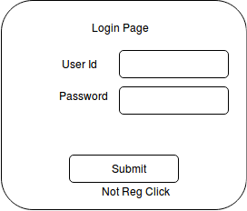

Dashboard Page:-

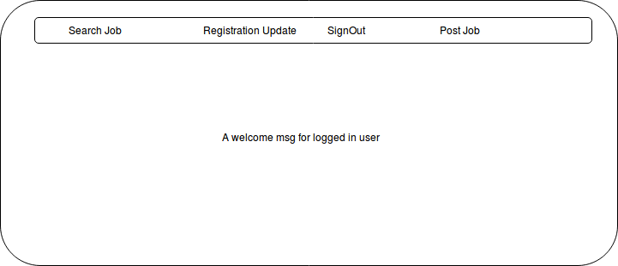

as per menu option clicked pages will appear:--

on clicking **Not Reg Click** on login page and also **Registration Update** menubar option then below page will appear for first time no value shown if coming from Not Reg Click option else will display candidate information for update as per logged in candidate.(here if a staff logged in to post a job then he wont see Registration candidate link ).

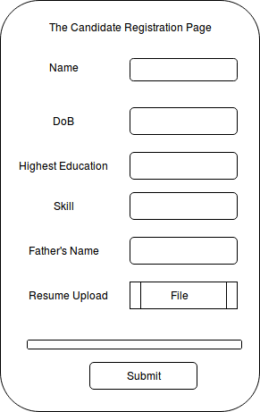

If a Staff logged in then he/she needs to post job for that (here if a candidate logged in then he wont see Post Job link) this below page:--

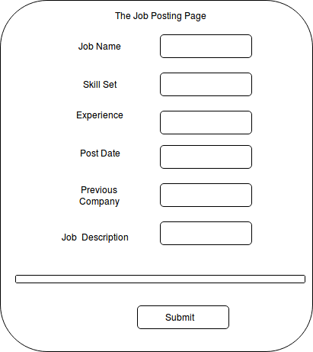

Job Search page for Candidate:-

